**DEVANGI PURKAYASTHA**

**REG NO-RA1811003010689**

**CSE D2**

# Date-27/04/2021

**AIM:- Intermediate code generation – Quadruple, Triple, Indirect triple**

**ALGORITHM:**

**CODE:-**

OPERATORS = set(['+', '-', '*', '/', '(', ')'])

PRI = {'+':1, '-':1, '*':2, '/':2}

### INFIX ===> POSTFIX ###

def infix_to_postfix(formula):

stack = [] # only pop when the coming op has priority

output = ''

for ch in formula:

if ch not in OPERATORS:

output += ch

elif ch == '(':

stack.append('(')

elif ch == ')':

while stack and stack[-1] != '(':

output += stack.pop()

stack.pop() # pop '('

else:

while stack and stack[-1] != '(' and PRI[ch] <= PRI[stack[-1]]:

output += stack.pop()

stack.append(ch)

# leftover

while stack:

output += stack.pop()

print(f'POSTFIX: {output}')

return output

### INFIX ===> PREFIX ###

def infix_to_prefix(formula):

op_stack = []

exp_stack = []

for ch in formula:

if not ch in OPERATORS:

exp_stack.append(ch)

elif ch == '(':

op_stack.append(ch)

elif ch == ')':

while op_stack[-1] != '(':

op = op_stack.pop()

a = exp_stack.pop()

b = exp_stack.pop()

exp_stack.append( op+b+a )

op_stack.pop() # pop '('

else:

while op_stack and op_stack[-1] != '(' and PRI[ch] <= PRI[op_stack[-1]]:

op = op_stack.pop()

a = exp_stack.pop()

b = exp_stack.pop()

exp_stack.append( op+b+a )

op_stack.append(ch)

# leftover

while op_stack:

op = op_stack.pop()

a = exp_stack.pop()

b = exp_stack.pop()

exp_stack.append( op+b+a )

print(f'PREFIX: {exp_stack[-1]}')

return exp_stack[-1]

### THREE ADDRESS CODE GENERATION ###

def generate3AC(pos):

print("### THREE ADDRESS CODE GENERATION ###")

exp_stack = []

t = 1

for i in pos:

if i not in OPERATORS:

exp_stack.append(i)

else:

print(f't{t} := {exp_stack[-2]} {i} {exp_stack[-1]}')

exp_stack=exp_stack[:-2]

exp_stack.append(f't{t}')

t+=1

expres = input("INPUT THE EXPRESSION: ")

pre = infix_to_prefix(expres)

pos = infix_to_postfix(expres)

generate3AC(pos)

def Quadruple(pos):

stack = []

op = []

x = 1

for i in pos:

if i not in OPERATORS:

stack.append(i)

elif i == '-':

op1 = stack.pop()

stack.append("t(%s)" %x)

print("{0:^4s} | {1:^4s} | {2:^4s}|{3:4s}".format(i,op1,"(-)"," t(%s)" %x))

x = x+1

if stack != []:

op2 = stack.pop()

op1 = stack.pop()

print("{0:^4s} | {1:^4s} | {2:^4s}|{3:4s}".format("+",op1,op2," t(%s)" %x))

stack.append("t(%s)" %x)

x = x+1

elif i == '=':

op2 = stack.pop()

op1 = stack.pop()

print("{0:^4s} | {1:^4s} | {2:^4s}|{3:4s}".format(i,op2,"(-)",op1))

else:

op1 = stack.pop()

op2 = stack.pop()

print("{0:^4s} | {1:^4s} | {2:^4s}|{3:4s}".format(i,op2,op1," t(%s)" %x))

stack.append("t(%s)" %x)

x = x+1

print("The quadruple for the expression ")

print(" OP | ARG 1 |ARG 2 |RESULT ")

Quadruple(pos)

def Triple(pos):

stack = []

op = []

x = 0

for i in pos:

if i not in OPERATORS:

stack.append(i)

elif i == '-':

op1 = stack.pop()

stack.append("(%s)" %x)

print("{0:^4s} | {1:^4s} | {2:^4s}".format(i,op1,"(-)"))

x = x+1

if stack != []:

op2 = stack.pop()

op1 = stack.pop()

print("{0:^4s} | {1:^4s} | {2:^4s}".format("+",op1,op2))

stack.append("(%s)" %x)

x = x+1

elif i == '=':

op2 = stack.pop()

op1 = stack.pop()

print("{0:^4s} | {1:^4s} | {2:^4s}".format(i,op1,op2))

else:

op1 = stack.pop()

if stack != []:

op2 = stack.pop()

print("{0:^4s} | {1:^4s} | {2:^4s}".format(i,op2,op1))

stack.append("(%s)" %x)

x = x+1

print("The triple for given expression")

print(" OP | ARG 1 |ARG 2 ")

Triple(pos)

**OUTPUT:**

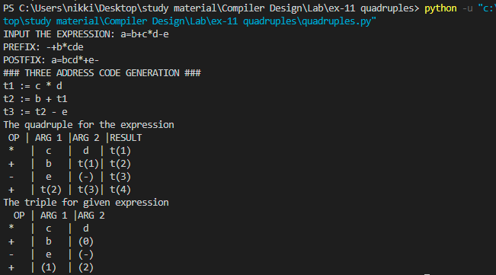

**OUTPUT:**

The given experiment has been successfully executed.